**Nama: Bryan Orville Audric**

**NIM: 2602160750  
KELAS: BC20-LAB**

**Database - Modul 1**

**Create Database**

CREATE DATABASE hehe_groceries;

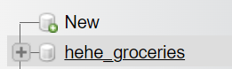

**Create Table**

CREATE TABLE MsCustomer

(

CustomerID CHAR(5) NOT NULL PRIMARY KEY,

CHECK(CustomerID REGEXP '^CU[0-9][0-9][0-9]$'),

CustomerName VARCHAR(50) NOT NULL,

CustomerGender VARCHAR(10) NOT NULL,

CustomerAddress VARCHAR(50) NOT NULL,

CustomerEmail VARCHAR(50) NOT NULL,

CustomerDOB DATE NOT NULL

);

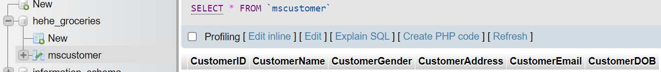

CREATE TABLE MsEmployee

(

EmployeeID CHAR(5) NOT NULL PRIMARY KEY,

CHECK(EmployeeID REGEXP '^EM[0-9][0-9][0-9]$'),

EmployeeName VARCHAR(50) NOT NULL,

EmployeeGender VARCHAR(10) NOT NULL,

EmployeeAddress VARCHAR(50) NOT NULL

);

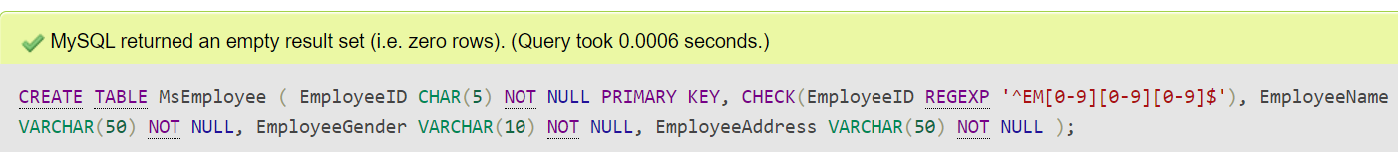

CREATE TABLE MsCategory

(

CategoryID CHAR(5) NOT NULL PRIMARY KEY,

CHECK(CategoryID REGEXP '^CT[0-9][0-9][0-9]$'),

CategoryName VARCHAR(50) NOT NULL

);

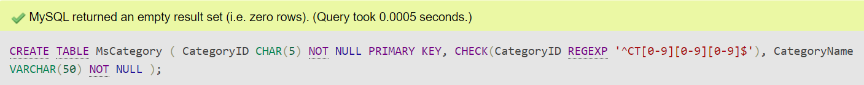

CREATE TABLE MsProduct

(

ProductID CHAR(5) NOT NULL PRIMARY KEY,

CHECK(ProductID REGEXP '^PR[0-9][0-9][0-9]$'),

CategoryID CHAR(5) NOT NULL,

FOREIGN KEY (CategoryID) REFERENCES mscategory(CategoryID) ON UPDATE CASCADE ON DELETE CASCADE,

ProductName VARCHAR(50) NOT NULL,

ProductPrice INT NOT NULL

);

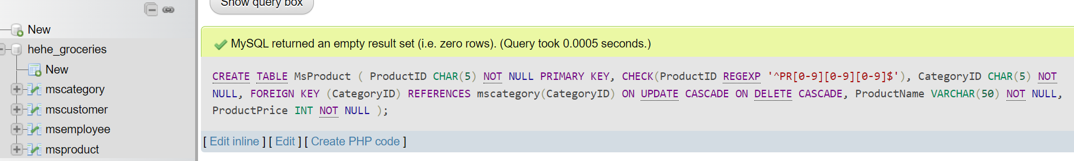

CREATE TABLE TransactionHeader

(

TransactionID CHAR(5) NOT NULL PRIMARY KEY,

CHECK(TransactionID REGEXP '^TR[0-9][0-9][0-9]$'),

EmployeeID CHAR(5) NOT NULL,

FOREIGN KEY (EmployeeID) REFERENCES msemployee(EmployeeID) ON UPDATE CASCADE ON DELETE CASCADE,

CustomerID CHAR(5) NOT NULL,

FOREIGN KEY (CustomerID) REFERENCES mscustomer(CustomerID) ON UPDATE CASCADE ON DELETE CASCADE,

TransactionDate Date NOT NULL

); 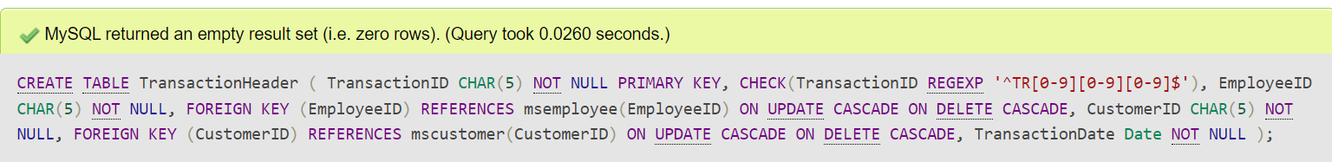

CREATE TABLE TransactionDetail

(

TransactionID CHAR(5) NOT NULL,

ProductID CHAR(5) NOT NULL,

PRIMARY KEY (TransactionID, ProductID),

FOREIGN KEY (TransactionID) REFERENCES transactionheader(TransactionID) ON UPDATE CASCADE ON DELETE CASCADE,

FOREIGN KEY (ProductID) REFERENCES msproduct(ProductID) ON UPDATE CASCADE ON DELETE CASCADE,

Quantity INT NOT NULL,

CHECK(Quantity > 0)

CREATE TABLE MsBrand

(

BrandID CHAR(5) NOT NULL PRIMARY KEY,

CHECK(BrandID REGEXP '^BR[0-9][0-9][0-9]$'),

BrandName VARCHAR(50) NOT NULL

);

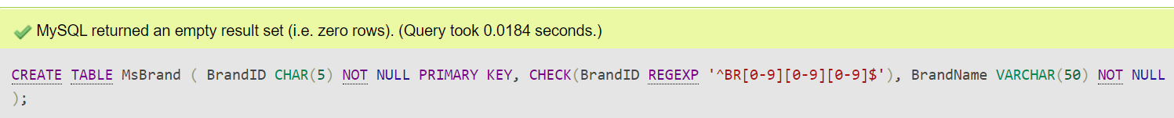

**Delete Table MsBrand**

DROP TABLE msbrand;

**Insert MsCustomer Table**

INSERT INTO mscustomer(CustomerID,CustomerName,CustomerGender,CustomerAddress,CustomerEmail,CustomerDOB)

VALUES ('CU001','Dirk Titterel','Male','74 Melvin Point','Dtitterel0@yellowpages.com','2003-10-29')



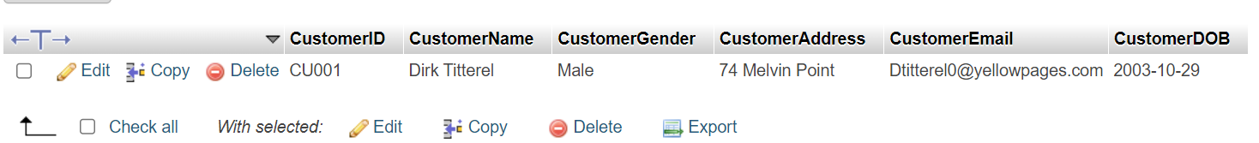

**Insert table MsEmployee**

INSERT INTO msemployee(EmployeeID,EmployeeName,EmployeeGender,EmployeeAddress)

VALUES

('EM001','Clem','Male','0975 Forest Dale Trail'),

('EM002','Dene','Male','2 Grayhawk Parkway'),

('EM003','Lethia','Female','905 Goodland Lane'),

('EM004','Tyrone','Male','51745 Bowman Hill'),

('EM005','Shanda','Male','848 New Castle Center')

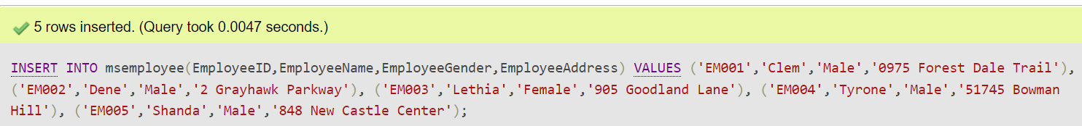

**Display all data from MsEmployee Table**

SELECT *FROM msemployee

**Display all data from a customer whose name is “Dirk Titterel”**

SELECT *

FROM mscustomer

WHERE CustomerName LIKE 'Dirk Titterel'

